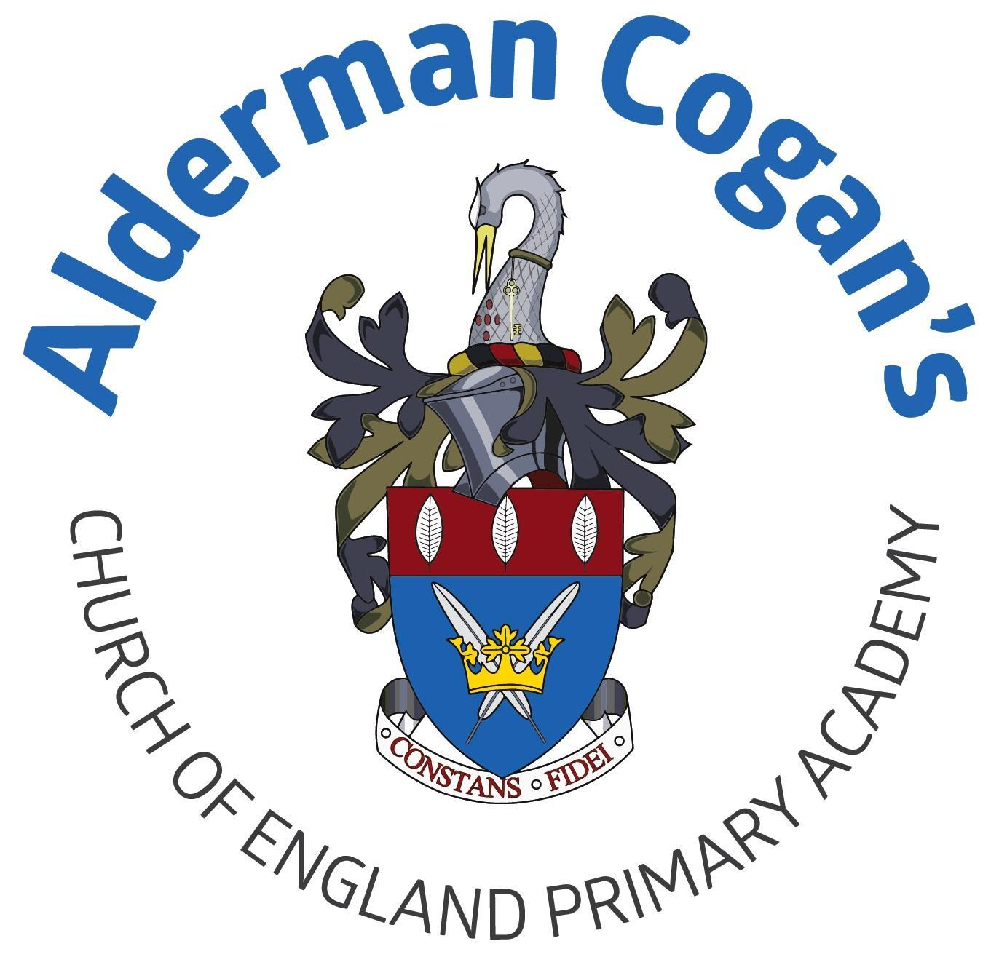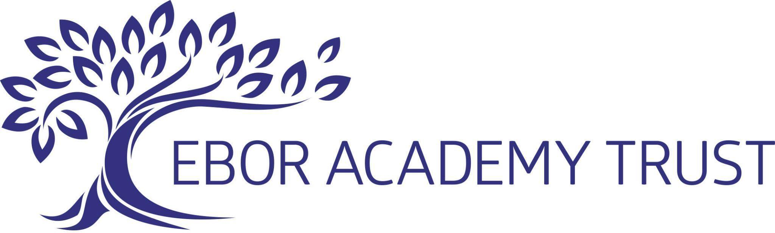

| **Year 1**  **Autumn**  **Human form**  **Topic: Our Wonderful World**  **Art**  **Funny faces and fabulous features** | | | | | |
| --- | --- | --- | --- | --- | --- |
| **Previous learning** | | | | | |
| This project teaches children about the concept of the portrait and how the collage technique can be used to make a portrait. Children will further their colour theory and portrait skills from the craft area in the Early Years unit. | | | | | |
| **Substantive Knowledge in Art** | | | **Disciplinary knowledge in Art** | | |
| The development of the formal elements by introducing and experiencing a wide range of media, using associated key vocabulary and knowing the work and techniques of a wide range of artists, craftspeople and designers. As pupils progress, they should be able to think critically and develop a more rigorous understanding of art and design as they develop skills and knowledge. They should also know how art and design both reflect and shape our history, and contribute to the culture, creativity and wealth of our nation. At the end of Key Stage Two, children of Alderman Cogan will be able to work independently to take action and refine their technical and craft skills in order to improve their mastery of materials and techniques. | | | Creatively thinking of possibilities, making comparisons, questioning and critiquing, reaching judgements, addressing challenges and reflecting on the impact of works of Art and Design produced independently, collectively and by others. Presenting outcomes verbally and in written form. | | |
| Sticky knowledge:   * Significant artists can be explored by describing their use of color, shape, materials, and subject matter. * Collage is an art technique of layering and sticking materials * A human face includes features like eyes, nose, and mouth, which can be represented in art using drawing, painting, or sculpture to show expressions, with sketches helping to communicate ideas. | | | | | |
| Lesson 1 | | **Exploring & Developing Ideas** | | | |
| * To be able to describe and explore the work of a significant artist. **(David Hockney, Patrick Bremer)** * To know words relating to colour, shape, materials and subject matter can be used to explore works by significant artists. | | | |
| Lesson 2 | | **Exploring & Developing Ideas** | | | |
| * To know that collage is an art technique where different materials are layered and stuck down to create artwork. **Experiment with different materials and get the children to glue and stick.** * Know that the primary colours are red, yellow and blue | | | |
| Lesson 3/4 | | **Exploring & Developing Ideas** | | | |
| * To know a human face includes features, such as eyes, nose, mouth, forehead, eyebrows and cheeks. * **To be able to represent the human face, using drawing, painting or sculpture and recognise expressions** * Can discuss how initial sketches can be used to communicate ideas and are part of the artistic process. | | | |
| Lesson 5 **(with staff on Seesaw - only thing in books is QR code)** | | **Evaluating & Developing Work** | | | |
| * Communicate their ideas simply after creating their artwork **(use seesaw to take a video of them evaluating what they like/dislike and to name the parts of the face) - QR code in artbooks. In groups** | | | |
| **Vocabulary** | | | | | |
| collage, expression, feature, portrait, self-portrait, ~~glue, sticking, paper~~ | | | | | |

| **Year 1**  **Spring**  **Topic: Bright Lights, Big City**  **Art** | | | | | |
| --- | --- | --- | --- | --- | --- |
| **Previous learning** | | | | | |
| In Art, the children will revisit the concept of different weather patterns, they will be introduced to the term “motif” and the pupils will create a weather motif. This project teaches children about collagraph printing, including how to develop a motif to make single and repeated prints. | | | | | |
| **Substantive Knowledge in Art** | | | **Disciplinary knowledge in Art** | | |
| The development of the formal elements by introducing and experiencing a wide range of media, using associated key vocabulary and knowing the work and techniques of a wide range of artists, craftspeople and designers. As pupils progress, they should be able to think critically and develop a more rigorous understanding of art and design as they develop skills and knowledge. They should also know how art and design both reflect and shape our history, and contribute to the culture, creativity and wealth of our nation. At the end of Key Stage Two, children of Alderman Cogan will be able to work independently to take action and refine their technical and craft skills in order to improve their mastery of materials and techniques. | | | Creatively thinking of possibilities, making comparisons, questioning and critiquing, reaching judgements, addressing challenges and reflecting on the impact of works of Art and Design produced independently, collectively and by others. Presenting outcomes verbally and in written form. | | |
| Sticky knowledge   * Explore and describe the work of significant art or artists * Soft pencils make dark lines, hard pencils make light lines, and different types of lines include zigzag, wavy, curved, thick, and thin. * A print is an image created by transferring ink, paint, or other media from one surface to another, and you can make prints and patterns using various liquids like ink and paint. | | | | | |
| Lesson 1 | | **Exploring & Developing Ideas** | | | |
| * To describe and explore the work of significant Art or Artists (weather print) | | | |
| Lesson 2 | | **Exploring & Developing Ideas** | | | |
| * To use soft and hard pencils to create different types of line and shape. * To know that soft pencils create darker lines and are marked with a B for black. Hard pencils create lighter lines and are marked with an H for hard. Different types of line include zigzag, wavy, curved, thick and thin. | | | |
| Lesson 3 | | **Exploring & Developing Ideas** | | | |
| * To know a print is a shape or image that has been made by transferring paint, fabric paint, ink or other media from one surface to another. * To make simple prints and patterns using a range of liquids including ink and paint. | | | |
| Lesson 4 | | **Evaluating & Developing Work** | | | |
| * Aspects of artwork that can be discussed include subject matter, use of colour and shape, the techniques used and the feelings the artwork creates. | | | |
| Lesson 5 | | **Evaluating & Developing Work:** | | | |
| * To say what they like about their own or others’ work using simple artistic vocabulary. | | | |
| **Vocabulary** | | | | | |
| dislike, evaluate, like, practice, success, feedback, discuss, evaluate, opinion, print, inks, experiment, shape, colour. | | | | | |

| **Year 1**  **Summer**  **Topic: School days**  **Art** | | | | | |
| --- | --- | --- | --- | --- | --- |
| **Previous learning** | | | | | |
| In Art, they revisit their knowledge of the colour wheel from the topic Mix It and they build upon their understanding of human features and local environment. This project teaches children about artwork depicting streets and buildings and focuses on the work of the American pop artist, James Rizzi. They create a 3-D mural based on Rizzi's work. | | | | | |
| **Substantive Knowledge in Art** | | | **Disciplinary knowledge in Art** | | |
| The development of the formal elements by introducing and experiencing a wide range of media, using associated key vocabulary and knowing the work and techniques of a wide range of artists, craftspeople and designers. As pupils progress, they should be able to think critically and develop a more rigorous understanding of art and design as they develop skills and knowledge. They should also know how art and design both reflect and shape our history, and contribute to the culture, creativity and wealth of our nation. At the end of Key Stage Two, children of Alderman Cogan will be able to work independently to take action and refine their technical and craft skills in order to improve their mastery of materials and techniques. | | | Creatively thinking of possibilities, making comparisons, questioning and critiquing, reaching judgements, addressing challenges and reflecting on the impact of works of Art and Design produced independently, collectively and by others. Presenting outcomes verbally and in written form. | | |
| Sticky knowledge   * Describe and explore the work of a significant artist using words related to color, shape, materials, and subject matter. * Drawings and paintings can be inspired by observation, imagination, or memory, and you can create artwork based on any of these sources. * Malleable materials, like clay, plasticine, and salt dough, can be shaped through techniques such as squeezing, pinching, pressing, rolling, and smoothing. | | | | | |
| Lesson 1 | | **Exploring & Developing Ideas** | | | |
| * To describe and explore the work of a significant artist. * To know words relating to colour, shape, materials and subject matter can be used to explore works by significant artists. | | | |
| Lesson 2 | | **Exploring & Developing Ideas** | | | |
| * To know drawings or paintings of locations can be inspired by observation (looking closely), imagination (creating pictures in the mind) and memory (remembering places from the past). * To be able to draw or paint a place from memory, imagination or observation | | | |
| Lesson 3 | | **Exploring & Developing Ideas** | | | |
| * To know that malleable materials include rigid and soft materials, such as clay, plasticine and salt dough * To be able to manipulate malleable materials by squeezing, pinching, pulling, pressing, rolling, modelling, flattening, poking, squashing and smoothing. | | | |
| Lesson 4 | | **Evaluating & Developing Work** | | | |
| * To talk about aspects of artwork that can be discussed include subject matter, use of colour and shape, the techniques used and the feelings the artwork creates. | | | |
| Lesson 5 | | **Evaluating & Developing Work:** | | | |
| * To say what they like about their own or others’ work using simple artistic vocabulary. | | | |
| **Vocabulary** | | | | | |
| building, cityscape, feature, street, urban, urban landscape, 3-D, form, layer, clay, tools, smooth, shape, rolling, pinching, twist | | | | | |