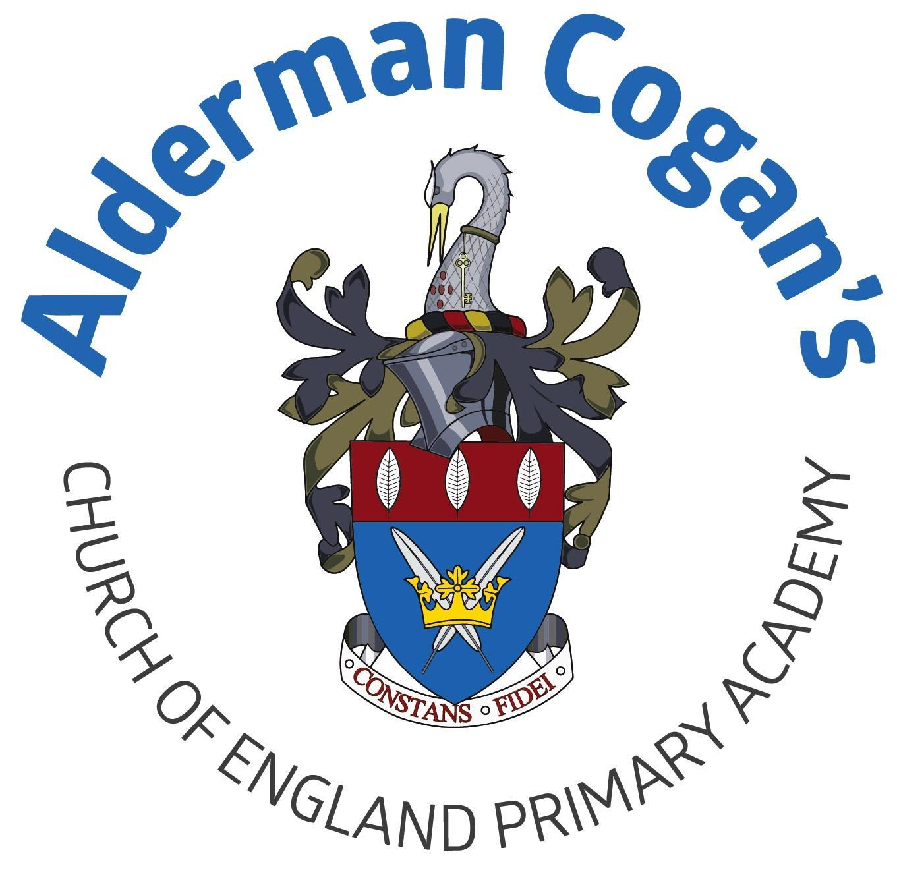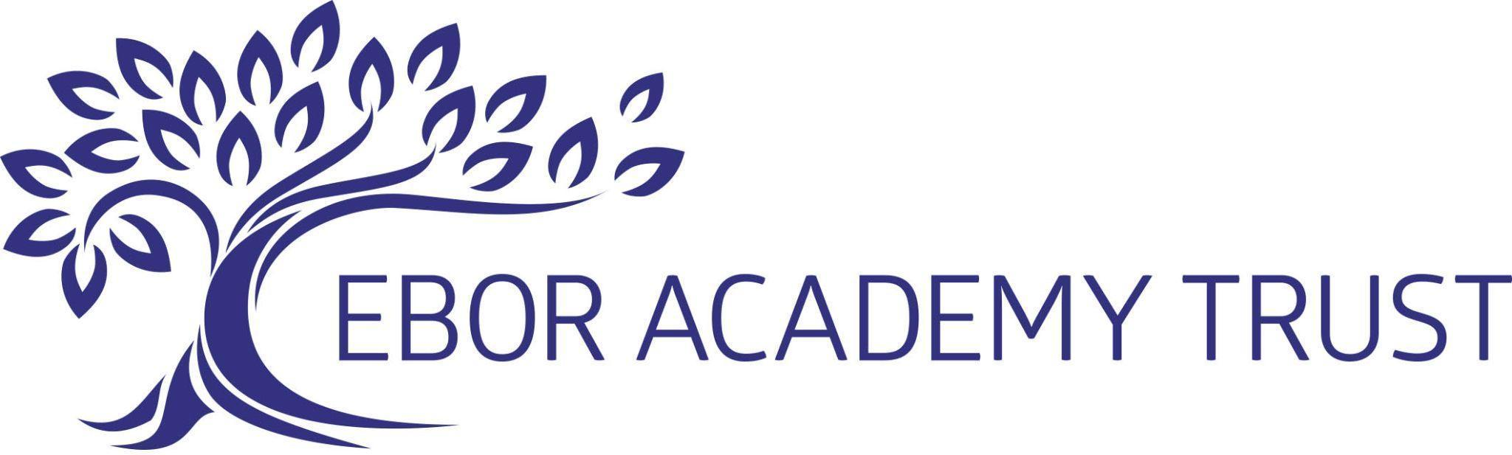

| **Year 2**  **Art**  **Autumn**  **Topic: Movers and Shakers** | | | | | |
| --- | --- | --- | --- | --- | --- |
| **Previous learning** | | | | | |
| In still life, the children learn about artists such as Vincent van Gogh and explore the use of colour in more depth. This project teaches children about the work of significant still life artists and still life techniques. They explore a wide variety of still lifes and learn about the use of colour and composition. They create still life arrangements and artwork. | | | | | |
| **Substantive Knowledge in Art** | | | **Disciplinary knowledge in Art** | | |
| The development of the formal elements by introducing and experiencing a wide range of media, using associated key vocabulary and knowing the work and techniques of a wide range of artists, craftspeople and designers. As pupils progress, they should be able to think critically and develop a more rigorous understanding of art and design as they develop skills and knowledge. They should also know how art and design both reflect and shape our history, and contribute to the culture, creativity and wealth of our nation. At the end of Key Stage Two, children of Alderman Cogan will be able to work independently to take action and refine their technical and craft skills in order to improve their mastery of materials and techniques. | | | Creatively thinking of possibilities, making comparisons, questioning and critiquing, reaching judgements, addressing challenges and reflecting on the impact of works of Art and Design produced independently, collectively and by others. Presenting outcomes verbally and in written form. | | |
| Sticky knowledge   * Artists make simple sketches to explore and develop ideas. * Textures like rough, smooth, ridged, and bumpy, along with tone, can be created with pencils, ink, and charcoal to make various patterns, textures, lines, and explore shape, form, and space. * Pencil, ink, and charcoal can create a variety of patterns, textures, and lines | | | | | |
| Lesson 1 | | **Exploring & Developing Ideas** | | | |
| * To know that a sketch is a quickly-produced or unfinished drawing, which helps artists develop their ideas. * To know that artists make simple sketches to explore and develop ideas.   . | | | |
| Lesson 2 | | **Exploring & Developing Ideas** | | | |
| * To understand that textures include rough, smooth, ridged and bumpy. Tone is the lightness or darkness of a colour. Pencils can create lines of different thicknesses and tones and can also be smudged. Ink can be used with a pen or brush to make lines and marks of varying thicknesses, and can be mixed with water and brushed on paper as a wash. Charcoal can be used to create lines of different thicknesses and tones, and can be rubbed onto paper and smudged * To be able to use the properties of pencil, ink and charcoal to create different patterns, textures and lines, and explore shape, form and space. | | | |
| Lesson 3 | | **Evaluating & Developing Work:** | | | |
| * To be able to use the properties of pencil, ink and charcoal to create different patterns, textures and lines, and explore shape, form and space. | | | |
| Lesson 4 | | **Evaluating & Developing Work:** | | | |
| * Analyse and evaluate their own and others' work using artistic vocabulary. | | | |
| **Vocabulary** | | | | | |
| describe, discuss, explore, investigate, sketch, colour, form, pattern, shape, sketch, visual element, represent, sketch | | | | | |

| **Year 2**  **Spring**  **Topic: Coastline**  **Art** | | | | | |
| --- | --- | --- | --- | --- | --- |
| **Previous learning** | | | | | |
| In art and design, children build on their understanding of sculptural forms through the subject matter of flowers. They build on their earlier experiences of relief sculpture in the Year 1 project Street view. This project teaches children about the visual elements of flowers, including shape, texture, colour, pattern and form. They also explore various artistic methods, including drawing, printmaking and 3-D forms, using paper and clay. | | | | | |
| **Substantive Knowledge in Art** | | | **Disciplinary knowledge in Art** | | |
| The development of the formal elements by introducing and experiencing a wide range of media, using associated key vocabulary and knowing the work and techniques of a wide range of artists, craftspeople and designers. As pupils progress, they should be able to think critically and develop a more rigorous understanding of art and design as they develop skills and knowledge. They should also know how art and design both reflect and shape our history, and contribute to the culture, creativity and wealth of our nation. At the end of Key Stage Two, children of Alderman Cogan will be able to work independently to take action and refine their technical and craft skills in order to improve their mastery of materials and techniques. | | | Creatively thinking of possibilities, making comparisons, questioning and critiquing, reaching judgements, addressing challenges and reflecting on the impact of works of Art and Design produced independently, collectively and by others. Presenting outcomes verbally and in written form. | | |
| Sticky knowledge   * Different art papers have unique textures, and you can create a variety of effects using media and techniques like frottage. * Malleable materials like clay, plasticine, and salt dough are easy to shape, while materials like tree bark, leaves, and bubble wrap can create textures, patterns, and imprints. * Create natural forms through drawing, painting, and sculpting from observation, imagination, or memory, and analyse artwork by focusing on subject, color, shape, form, and texture. * A block print is made by carving a pattern onto a surface like clay or polystyrene, inking it, and pressing it onto paper or fabric to transfer the design, which can be repeated. | | | | | |
| Lesson 1 | | **Exploring & Developing Ideas** | | | |
| * To know that art papers have different weights and textures. For example, watercolour paper is heavy and has a rough surface, drawing paper is of a medium weight and has a fairly smooth surface and handmade paper usually has a rough, uneven surface with visible fibres. Different media, such as pastels, or watercolour paint, can be added to papers to reveal texture and the rubbing technique, frottage, can be used to create a range of effects on different papers * Can create a range of textures using the properties of different types of paper. | | | |
| Lesson 2 | | **Exploring & Developing Ideas** | | | |
| * To know that malleable materials, such as clay, plasticine or salt dough, are easy to shape. Interesting materials that can make textures, patterns and imprints include tree bark, leaves, nuts and bolts and bubble wrap. | | | |
| Lesson 3 | | **Exploring & Developing Ideas** | | | |
| * Are able to press objects into a malleable material to make textures, patterns and imprints. | | | |
| Lesson 4 | | **Evaluating & Developing Work** | | | |
| * Draw, paint and sculpt natural forms from observation, imagination and memory * To talk about aspects of artwork to analyse and evaluate include subject matter, colour, shape, form and texture. | | | |
| Lesson 5 | | **Evaluating & Developing Work** | | | |
| * To know that a block print is made when a pattern is carved or engraved onto a surface,such as clay or polystyrene, covered with ink, and then pressed onto paper or fabric to transfer the ink. The block can be repeatedly used, creating a repeating pattern. * Use the properties of various materials, such as clay or polystyrene, to develop a block print. | | | |
| Lesson 6 | | **Evaluating & Developing Work** | | | |
| * To analyse and evaluate their own and others' work using artistic vocabulary. | | | |
| describe, discuss, explore, investigate, sketch, colour, form, pattern, shape, sketch, visual element, represent, sketch | | | | | |

| **Year 2**  **Summer**  **Magnificent Monarchs**  **Art** | | | | | |
| --- | --- | --- | --- | --- | --- |
| **Previous learning** | | | | | |
| In art and design, children’s understanding of monarchy and power is connected. Children revisit the theme of portraiture initially studied in the Year 1 project Funny Faces and Fabulous Features and the concept of monarchy introduced in the Year 1 project Bright Lights, Big City. They use art software to create simple line drawings, again building on their experiences in Year 1. This project teaches children about portraiture. They analyse the portraits of Tudor monarchs and compare Tudor portraits and selfies today. They use photo editing software to create royal portraits. | | | | | |
| **Substantive Knowledge in Art** | | | **Disciplinary knowledge in Art** | | |
| The development of the formal elements by introducing and experiencing a wide range of media, using associated key vocabulary and knowing the work and techniques of a wide range of artists, craftspeople and designers. As pupils progress, they should be able to think critically and develop a more rigorous understanding of art and design as they develop skills and knowledge. They should also know how art and design both reflect and shape our history, and contribute to the culture, creativity and wealth of our nation. At the end of Key Stage Two, children of Alderman Cogan will be able to work independently to take action and refine their technical and craft skills in order to improve their mastery of materials and techniques. | | | Creatively thinking of possibilities, making comparisons, questioning and critiquing, reaching judgements, addressing challenges and reflecting on the impact of works of Art and Design produced independently, collectively and by others. Presenting outcomes verbally and in written form. | | |
| Sticky knowledge   * Artwork reflects the skill of the artist, influences others, represents a style or movement, features meaningful subjects, or expresses the artist’s ideas and long-term body of work * .A drawing, painting, or sculpture of a human face is called a portrait. * Represent the human form, including the face and features, through observation, imagination, or memory. | | | | | |
| Lesson 1 | | **Exploring & Developing Ideas** | | | |
| * To be able to explain why a painting, piece of artwork, body of work or artist is important. * To know why works of art are important for many reasons: they were created by famous or highly skilled artists; they influenced the artwork of others; they clearly show the features of a style or movement of art; the subject matter is interesting or important; they show the thoughts and ideas of the artist or the artist created a large body of work over a long period of time. | | | |
| Lesson 2 | | **Exploring & Developing Ideas** | | | |
| * To know a drawing, painting or sculpture of a human face is called a portrait. * To make simple sketches to explore and develop ideas. | | | |
| Lesson 3 | | **Exploring & Developing Ideas** | | | |
| * To be able to represent the human form, including face and features, from observation, imagination or memory | | | |
| Lesson 4 | | **Evaluating & Developing Work** | | | |
| * To understand aspects of artwork to analyse and evaluate include subject matter, colour, shape, form and texture. | | | |
| Lesson 5 | | **Evaluating & Developing Work:** | | | |
| * To analyse and evaluate their own and others' work using artistic vocabulary. | | | |
| **Vocabulary** | | | | | |
| portrait, pose, posture, evaluate, practice, successful, analyse, different, dislike, evaluate, like, similar, discuss, evaluate, improve, success, feedback | | | | | |

| **Year 2**  **Summer**  **Magnificent Monarchs**  **Landscapes**  **Art** | | | | | |
| --- | --- | --- | --- | --- | --- |
| **Previous learning** | | | | | |
| In art and design, children’s understanding of monarchy and power is connected. In this topic children look at landscapes. This follows from the work they have done about observations drawing in year 1. | | | | | |
| **Substantive Knowledge in Art** | | | **Disciplinary knowledge in Art** | | |
| The development of the formal elements by introducing and experiencing a wide range of media, using associated key vocabulary and knowing the work and techniques of a wide range of artists, craftspeople and designers. As pupils progress, they should be able to think critically and develop a more rigorous understanding of art and design as they develop skills and knowledge. They should also know how art and design both reflect and shape our history, and contribute to the culture, creativity and wealth of our nation. At the end of Key Stage Two, children of Alderman Cogan will be able to work independently to take action and refine their technical and craft skills in order to improve their mastery of materials and techniques. | | | Creatively thinking of possibilities, making comparisons, questioning and critiquing, reaching judgements, addressing challenges and reflecting on the impact of works of Art and Design produced independently, collectively and by others. Presenting outcomes verbally and in written form. | | |
| Lesson 1 | | **Exploring & Developing Ideas** | | | |
| * To know a landscape is a piece of artwork that shows a scenic view | | | |
| Lesson 2 | | **Exploring & Developing Ideas** | | | |
| * To be able to draw or paint features of landscape from memory, imagination or observation, with some attention to detail. | | | |
| **Vocabulary** | | | | | |
| building, cityscape, feature, street, urban, urban landscape | | | | | |