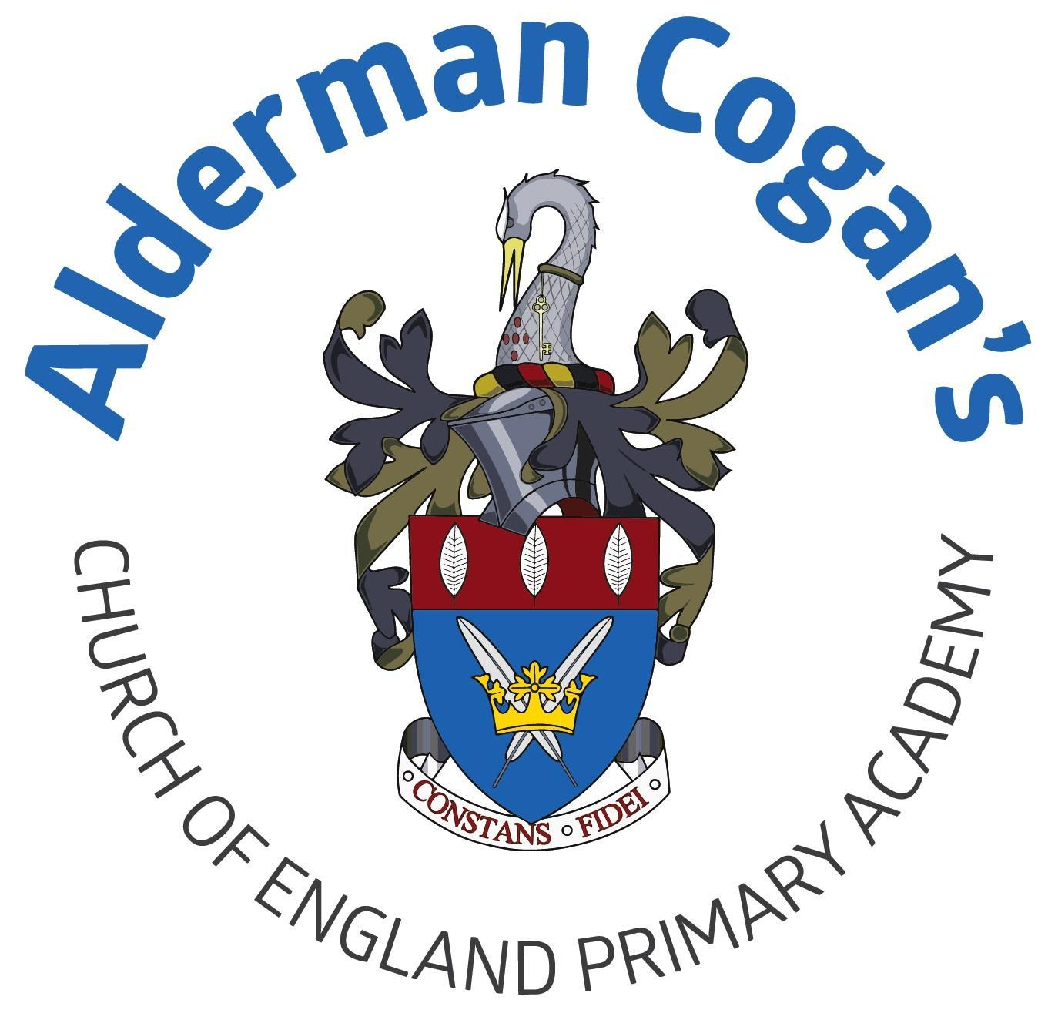

| **Year 3**  **Through the Ages**  **Art**  **Autumn** | | | | | |
| --- | --- | --- | --- | --- | --- |
| **Previous learning** | | | | | |
| In art children build on the key stage one unit Mix It revising and extending their knowledge of colour theory. They will revise the concept of the colour wheel and be introduced to watercolour paints. This project teaches children about colour theory by studying the colour wheel and colour mixing. It includes an exploration of tertiary colours, warm and cool colours, complementary colours and analogous colours, and how artists use colour in their artwork. | | | | | |
| **Substantive Knowledge in Art** | | | **Disciplinary knowledge in Art** | | |
| The development of the formal elements by introducing and experiencing a wide range of media, using associated key vocabulary and knowing the work and techniques of a wide range of artists, craftspeople and designers. As pupils progress, they should be able to think critically and develop a more rigorous understanding of art and design as they develop skills and knowledge. They should also know how art and design both reflect and shape our history, and contribute to the culture, creativity and wealth of our nation. At the end of Key Stage Two, children of Alderman Cogan will be able to work independently to take action and refine their technical and craft skills in order to improve their mastery of materials and techniques. | | | Creatively thinking of possibilities, making comparisons, questioning and critiquing, reaching judgements, addressing challenges and reflecting on the impact of works of Art and Design produced independently, collectively and by others. Presenting outcomes verbally and in written form. | | |
| Sticky knowledge   * Contrasting colours are opposite each other on the colour wheel * Colours can be a mixture of two colours * A two-color print can be made by inking a roller and transferring it onto a block | | | | | |
| Lesson 1 | | **Exploring & Developing Ideas** | | | |
| * To give examples of contrasting colours include red and green, blue and orange, and yellow and purple (violet). To know they are obviously different to one another and are opposite each other on the colour wheel. | | | |
| Lesson 2 | | **Exploring & Developing Ideas** | | | |
| * Can identify, mix and use contrasting coloured paints. | | | |
| Lesson 3 | | **Exploring & Developing Ideas** | | | |
| * To know that two-colour print can be made in different ways, such as by inking a roller before transferring it onto a block, creating a full print then masking areas of the printing block before printing again with a different colour or creating a full print then cutting away areas of the printing block before printing again | | | |
| Lesson 4 | | **Evaluating & Developing Work** | | | |
| * Make a two-colour print | | | |
| **Vocabulary** | | | | | |
| primary, secondary, mix, shades, experiment, effects, textures, blocking, washes, layering, | | | | | |

| **Year 3**  **Spring**  **Rocks, Relics and Rumbles**  **Art** | | | | | |
| --- | --- | --- | --- | --- | --- |
| **Previous learning** | | | | | |
| In Art, the children will revisit the theme of nature as a starting point. They will build upon their knowledge of “motif” which was introduced in Year 1. This project teaches children about artistic techniques used in sketching, printmaking and sculpture. | | | | | |
| **Substantive Knowledge in Art** | | | **Disciplinary knowledge in Art** | | |
| The development of the formal elements by introducing and experiencing a wide range of media, using associated key vocabulary and knowing the work and techniques of a wide range of artists, craftspeople and designers. As pupils progress, they should be able to think critically and develop a more rigorous understanding of art and design as they develop skills and knowledge. They should also know how art and design both reflect and shape our history, and contribute to the culture, creativity and wealth of our nation. At the end of Key Stage Two, children of Alderman Cogan will be able to work independently to take action and refine their technical and craft skills in order to improve their mastery of materials and techniques. | | | Creatively thinking of possibilities, making comparisons, questioning and critiquing, reaching judgements, addressing challenges and reflecting on the impact of works of Art and Design produced independently, collectively and by others. Presenting outcomes verbally and in written form. | | |
| Sticky knowledge   * Explore contemporary sculptures based on natural forms. * Preliminary sketches are quick pencil drawings used to inspire artwork. * Preliminary sketches help communicate ideas and experiment with techniques, while hatching, cross-hatching, scumbling, and stippling add tone, texture, and form to a drawing. * Malleable materials are easy to shape, while rigid materials require cutting and joining. | | | | | |
| Lesson 1 | | **Exploring & Developing Ideas** | | | |
| * To explore contemporary sculptures based on natural forms include *Ammonite Slice Outside*, by Mark Reed; *Coil Shell*, by Lucy Unwin; *Dark at Heart*, by Peter Randall-Page; and the *Chintz Series*, by Peter Garrard. | | | |
| Lesson 2 | | **Exploring & Developing Ideas** | | | |
| * To know preliminary sketches are quick drawings that can be used to inspire a final piece of artwork. They are often line drawings that are done in pencil | | | |
| Lesson 3 | | **Exploring & Developing Ideas** | | | |
| * To be able to use preliminary sketches in a sketchbook to communicate an idea or experiment with a technique * To be able to add tone to a drawing by using linear and cross-hatching, scumbling and stippling. * To be able to add hatching, cross-hatching and shading are techniques artists use to add texture and form | | | |
| Lesson 4 | | **Evaluating & Developing Work** | | | |
| * To understand that malleable materials, such as clay, papier-mâché and Modroc, are easy to change into a new shape. Rigid materials, such as cardboard, wood or plastic, are more difficult to change into a new shape and may need to be cut and joined together using a variety of techniques * To create a 3-D form using malleable or rigid materials, or a combination of materials * Make suggestions for ways to adapt and improve a piece of artwork. | | | |
| Lesson 5 | | **Evaluating & Developing Work:** | | | |
| * To understand suggestions for improving or adapting artwork could include aspects of the subject matter, structure and composition; the execution of specific techniques or the uses of colour, line, texture, tone, shadow and shading. * To be able to make suggestions for ways to adapt and improve a piece of artwork. | | | |
| **Vocabulary** | | | | | |
| 3-D, clay, coil, form, roll, sculpture, create, patterns, join, modelling, clay, coils, slips, malleable. | | | | | |

| **Year 3**  **Summer**  **Emperors and Empires** **Beautiful Botanicals****Art** | | | | | |
| --- | --- | --- | --- | --- | --- |
| **Previous learning** | | | | | |
| This project teaches children about the genre of botanical art. They create natural weavings, two-colour prints and beautiful and detailed botanical paintings of fruit. | | | | | |
| **Substantive Knowledge in Art** | | | **Disciplinary knowledge in Art** | | |
| The development of the formal elements by introducing and experiencing a wide range of media, using associated key vocabulary and knowing the work and techniques of a wide range of artists, craftspeople and designers. As pupils progress, they should be able to think critically and develop a more rigorous understanding of art and design as they develop skills and knowledge. They should also know how art and design both reflect and shape our history, and contribute to the culture, creativity and wealth of our nation. At the end of Key Stage Two, children of Alderman Cogan will be able to work independently to take action and refine their technical and craft skills in order to improve their mastery of materials and techniques. | | | Creatively thinking of possibilities, making comparisons, questioning and critiquing, reaching judgements, addressing challenges and reflecting on the impact of works of Art and Design produced independently, collectively and by others. Presenting outcomes verbally and in written form. | | |
| Sticky knowledge   * Warp and weft are the two basic components in loom weaving * Weaving can be natural or man-made materials * Artwork can be a combined range of visual elements. * Significant artists can be inspired from their culture. | | | | | |
| Lesson 1 | | **Exploring & Developing Ideas** | | | |
| * Warp and weft are terms for the two basic components used in loom weaving. The lengthwise warp yarns are fixed onto a frame or loom, while the weft yarns are woven horizontally over and under the warp yarns. | | | |
| Lesson 2 | | **Exploring & Developing Ideas** | | | |
| * Weave natural or man-made materials on cardboard looms, making woven pictures or patterns. | | | |
| Lesson 3 | | **Exploring & Developing Ideas** | | | |
| * To use and combine a range of visual elements in artwork. * To work in the style of a significant artist, architect, culture or designer | | | |
| Lesson 4 | | **Evaluating & Developing Work** | | | |
| * To use and combine a range of visual elements in artwork. * To work in the style of a significant artist, architect, culture or designer | | | |
| Lesson 5 | | **Evaluating & Developing Work:** | | | |
| * Make suggestions for ways to adapt and improve a piece of artwork | | | |
| **Vocabulary** | | | | | |
| tearing, overlapping and layering | | | | | |