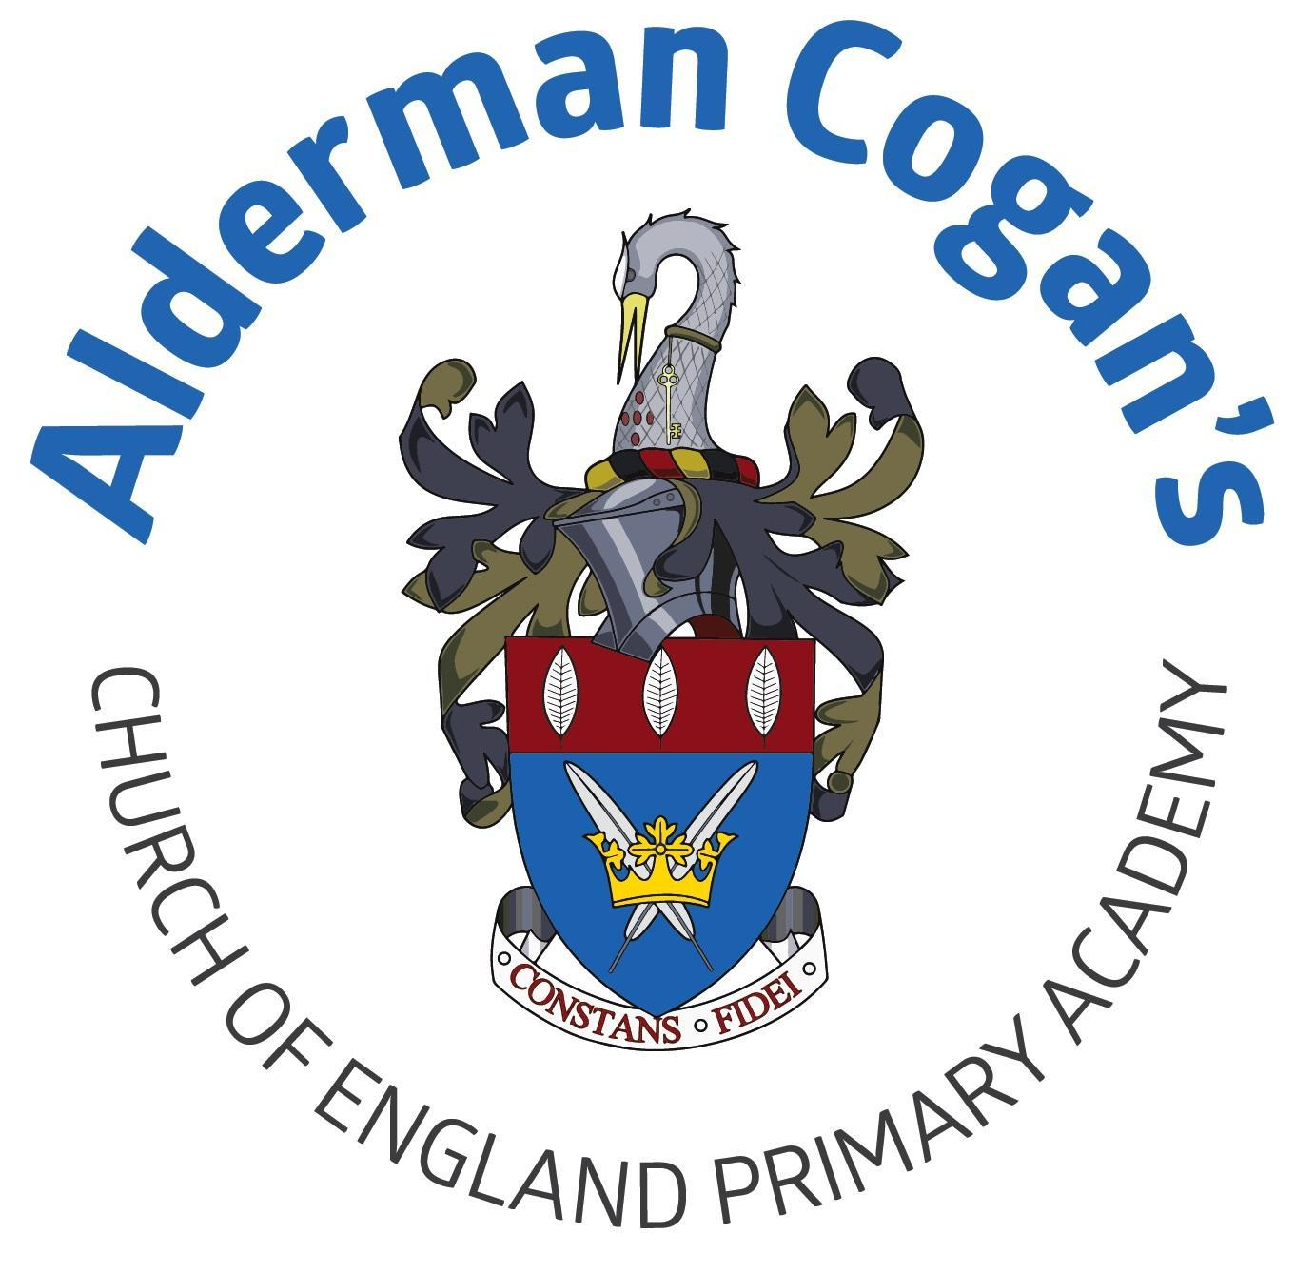

| **Year 4**  **Autumn**  **Invasion**  **Contrast and complement colour mixing**  **Art** | | | | | |
| --- | --- | --- | --- | --- | --- |
| **Previous learning** | | | | | |
| In art, children build on learning from the Mix it projects in Year 1 and Year 2, and the Contrast and Complement project in Year 3. Children revisit and extend their understanding of colour and colour theory by learning colour families, including analogous, complementary, warm, cool and tertiary colours. This project teaches children about colour theory by studying the colour wheel and colour mixing. It includes an exploration of tertiary colours, warm and cool colours, complementary colours and analogous colours, and how artists use colour in their artwork. | | | | | |
| **Substantive Knowledge in Art** | | | **Disciplinary knowledge in Art** | | |
| The development of the formal elements by introducing and experiencing a wide range of media, using associated key vocabulary and knowing the work and techniques of a wide range of artists, craftspeople and designers. As pupils progress, they should be able to think critically and develop a more rigorous understanding of art and design as they develop skills and knowledge. They should also know how art and design both reflect and shape our history, and contribute to the culture, creativity and wealth of our nation. At the end of Key Stage Two, children of Alderman Cogan will be able to work independently to take action and refine their technical and craft skills in order to improve their mastery of materials and techniques. | | | Creatively thinking of possibilities, making comparisons, questioning and critiquing, reaching judgements, addressing challenges and reflecting on the impact of works of Art and Design produced independently, collectively and by others. Presenting outcomes verbally and in written form. | | |
| Sticky knowledge   * Artists sketches help artists develop ideas and refine techniques over time. * Creating sketches over time helps develop ideas and improve techniques. * Warm colors like red, orange, and yellow evoke heat and happiness, while cool colors like blue and green suggest calmness or loneliness, and both can be identified, mixed, and used to create mood in a painting. * Primary, secondary, and complementary colors can be mixed with watercolors to create unique effects. | | | | | |
| Lesson 1 | | **Exploring & Developing Ideas** | | | |
| * To know that artists use sketching to develop an idea over time. * To be able to create a series of sketches over time to develop ideas on a theme or mastery of a technique. | | | |
| Lesson 2 | | **Exploring & Developing Ideas** | | | |
| * To be able to create a series of sketches over time to develop ideas on a theme or mastery of a technique | | | |
| Lesson 3 | | **Exploring & Developing Ideas** | | | |
| * To know that warm colours include orange, yellow and red. They remind the viewer of heat, fire and sunlight. They can make people feel happy and they look like they are in the foreground of a picture. Cool colours include blue, green and magenta. Cool colours remind the viewer of water, ice, snow and the sky. They can make people feel calm or lonely and they recede into the background of a picture. * To be able to identify, mix and use warm and cool paint colours to evoke warmth or coolness in a painting. | | | |
| Lesson 4 | | **Evaluating & Developing Work** | | | |
| * To be able to mix, effects, primary secondary and complementary colours, watercolours, imagination | | | |
| Lesson 5 | | **Evaluating & Developing Work:** | | | |
| * To understand that constructive feedback highlights strengths and weaknesses and provides information and instructions aimed at improving one or two aspects of the artwork, which will improve the overall piece. * Can give constructive feedback to others about ways to improve a piece of artwork. | | | |
| **Vocabulary** | | | | | |
| colour mixing, layering, palette, sketchbook, translucency, watercolour paint, design, sketch, colour, combine, shade, sketch, tone | | | | | |

| **Year 4**  **Spring**  **Misty Mountain, Winding river**  **Art** | | | | | |
| --- | --- | --- | --- | --- | --- |
| **Previous learning** | | | | | |
| In art, the children will use their previous knowledge about colour theory and colour mixing to create landscape artwork.  Vista- this project teaches children about the techniques that artists use when composing landscape images, such as colour and atmosphere. In art, the children will use their previous knowledge about colour theory and colour mixing to create landscape artwork. | | | | | |
| **Substantive Knowledge in Art** | | | **Disciplinary knowledge in Art** | | |
| The development of the formal elements by introducing and experiencing a wide range of media, using associated key vocabulary and knowing the work and techniques of a wide range of artists, craftspeople and designers. As pupils progress, they should be able to think critically and develop a more rigorous understanding of art and design as they develop skills and knowledge. They should also know how art and design both reflect and shape our history, and contribute to the culture, creativity and wealth of our nation. At the end of Key Stage Two, children of Alderman Cogan will be able to work independently to take action and refine their technical and craft skills in order to improve their mastery of materials and techniques. | | | Creatively thinking of possibilities, making comparisons, questioning and critiquing, reaching judgements, addressing challenges and reflecting on the impact of works of Art and Design produced independently, collectively and by others. Presenting outcomes verbally and in written form. | | |
| Sticky knowledge | | | | | |
| Lesson 1 | | **Exploring & Developing Ideas** | | | |
| * To be able to compare and contrast artwork from different times and cultures. | | | |
| Lesson 2 | | **Exploring & Developing Ideas** | | | |
| * To explore how Art can display interesting or unusual perspectives and viewpoints. * To be able to choose an interesting or unusual perspective or viewpoint for a landscape | | | |
| Lesson 3 | | **Exploring & Developing Ideas** | | | |
| * To know that pen and ink create dark lines that strongly contrast with white paper. Pen and ink techniques include hatching (drawing straight lines in the same direction to fill in an area), cross-hatching (layering lines of hatching in different directions), random lines (drawing lines of a variety of shapes and lengths) and stippling (using small dots). Light tones are created when lines or dots are drawn further apart and dark tones are created when lines or dots are drawn closer together * To use the properties of pen, ink and charcoal to create a range of effects in drawing. | | | |
| Lesson 4 | | **Evaluating & Developing Work** | | | |
| * To identify, mix and use warm and cool paint colours to evoke warmth or coolness in a painting. | | | |
| Lesson 5 | | **Evaluating & Developing Work:** | | | |
| * To be able to give constructive feedback to others about ways to improve a piece of artwork | | | |
| **Vocabulary** | | | | | |
| atmospheric perspective, landscape, scenery | | | | | |

| **Year 4**  **Summer** **Statues, Statuettes and Figurines****Art** | | | | | |
| --- | --- | --- | --- | --- | --- |
| **Previous learning** | | | | | |
| This project teaches children about the 3-D representation of the human form, including statues, statuettes and figurines. They study examples from ancient civilisations, and use their clay skills to create a Sumer-style figurine. The children will use their knowledge about the human form from previous year groups in order to create a Sumer-style figurine. | | | | | |
| **Substantive Knowledge in Art** | | | **Disciplinary knowledge in Art** | | |
| The development of the formal elements by introducing and experiencing a wide range of media, using associated key vocabulary and knowing the work and techniques of a wide range of artists, craftspeople and designers. As pupils progress, they should be able to think critically and develop a more rigorous understanding of art and design as they develop skills and knowledge. They should also know how art and design both reflect and shape our history, and contribute to the culture, creativity and wealth of our nation. At the end of Key Stage Two, children of Alderman Cogan will be able to work independently to take action and refine their technical and craft skills in order to improve their mastery of materials and techniques. | | | Creatively thinking of possibilities, making comparisons, questioning and critiquing, reaching judgements, addressing challenges and reflecting on the impact of works of Art and Design produced independently, collectively and by others. Presenting outcomes verbally and in written form. | | |
| Sticky knowledge   * Art can depict the human form to tell a story or create a narrative. * Explore and develop three-dimensional art using the human form, inspired by contemporary or historical ideas. * Clay can be shaped into detailed or experimental 3-D forms using different techniques. * **Stitches such as running stitch, cross stitch, and blanket stitch can be used to add detail and texture to fabric or mixed-media collages.** | | | | | |
| Lesson 1 | | **Exploring & Developing Ideas** | | | |
| * Understand that art can be developed that depicts the human form to create a narrative. | | | |
| Lesson 2 | | **Exploring & Developing Ideas** | | | |
| * Explore and develop three-dimensional art that uses the human form, using ideas from contemporary or historical starting points | | | |
| Lesson 3 | | **Exploring & Developing Ideas** | | | |
| * Can use clay to create a detailed or experimental 3-D form. * Understand that techniques used to create a 3-D form from clay include coiling, pinching, slab construction and sculpting. Carving, slip and scoring can be used to attach extra pieces of clay. Mark making can be used to add detail to 3-D forms | | | |
| Lesson 4 | | **Evaluating & Developing Work** | | | |
| * Give constructive feedback to others about ways to improve a piece of artwork. * To know constructive feedback highlights strengths and weaknesses and provides information and instructions aimed at improving one or two aspects of the artwork, which will improve the overall piece | | | |
| Lesson 5 | | **Evaluating & Developing Ideas:** | | | |
| * Understand that stitches include running stitch, cross stitch and blanket stitch. * Can use a range of stitches to add detail and texture to fabric or mixed-media collages. | | | |
| **Vocabulary** | | | | | |
| 3-D, feature, figurine, human form, statue, statuette, 3-D form, carving, clay, cross-hatch, join, score, sculpting, sculpture, shape, slabbing, smoothing, texture, twist wire frame, construct, surface patterns, join, modelling, clay, coils, slips, malleable. | | | | | |