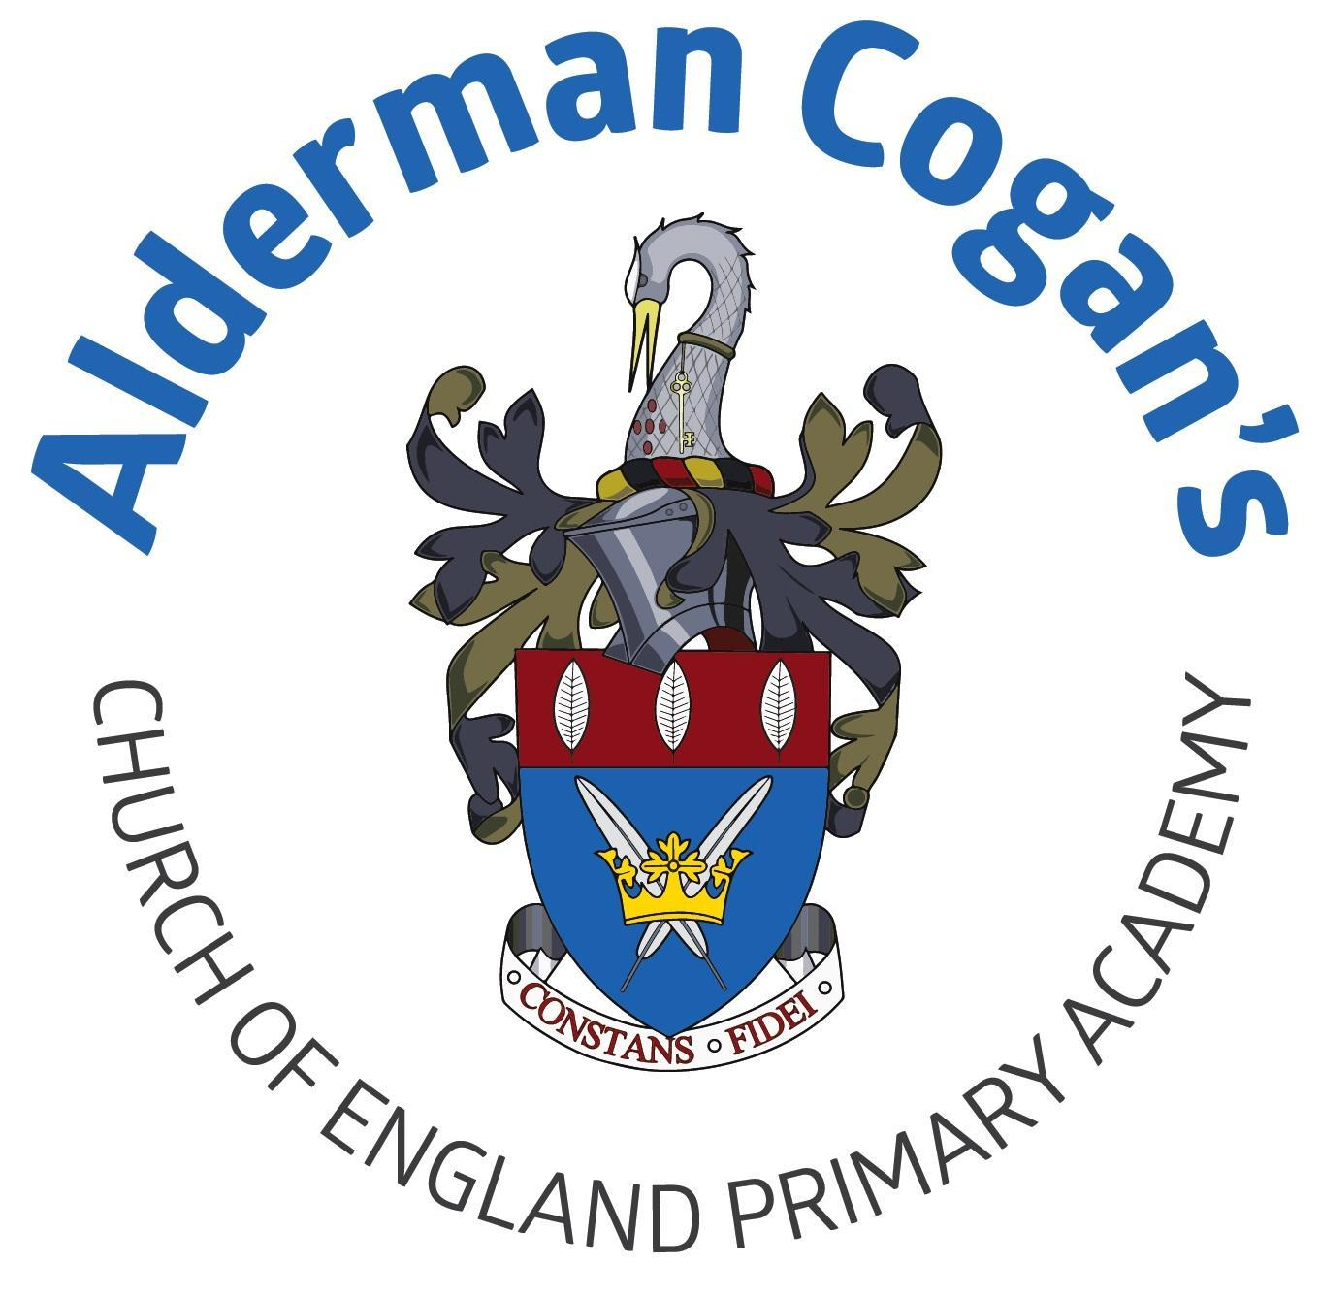

| **Year 5**  **Autumn**  **Dynamic Dynasties**  **Tint, tone and shade**  **Art** | | | | | |
| --- | --- | --- | --- | --- | --- |
| **Previous learning**  In art, children revisit and extend their understanding of colour theory from Year 3 and Year 4. They are introduced to the terms, tint, tone and shade and they build on their understanding of the genre previously explored in the Year 4 Vista project. Children revisit watercolour which was introduced in Year 3 and Year 4. This project teaches children about colour theory by studying the colour wheel and exploring mixing tints, shades and tones. They learn about significant landscape artworks and features of landscapes before using this knowledge to create landscape paintings. | | | | | |
| **Substantive Knowledge in Art** | | | **Disciplinary knowledge in Art** | | |
| The development of the formal elements by introducing and experiencing a wide range of media, using associated key vocabulary and knowing the work and techniques of a wide range of artists, craftspeople and designers. As pupils progress, they should be able to think critically and develop a more rigorous understanding of art and design as they develop skills and knowledge. They should also know how art and design both reflect and shape our history, and contribute to the culture, creativity and wealth of our nation. At the end of Key Stage Two, children of Alderman Cogan will be able to work independently to take action and refine their technical and craft skills in order to improve their mastery of materials and techniques. | | | Creatively thinking of possibilities, making comparisons, questioning and critiquing, reaching judgements, addressing challenges and reflecting on the impact of works of Art and Design produced independently, collectively and by others. Presenting outcomes verbally and in written form. | | |
| Sticky knowledge   * Tints are colours mixed with white to lighten, shades are colours mixed with black to darken. * Imaginative and fantasy landscapes are creative artworks inspired by traditional landscape features * Artists use ideas to express thoughts and messages, and methods and approaches are the techniques they use to create their work. | | | | | |
| Lesson 1 | | **Exploring & Developing Ideas** | | | |
| * To know that a tint is a colour mixed with white, which increases lightness, and a shade is a colour mixed with black, which increases darkness. * To be able to mix and use tints and shades of colours using a range of different materials, including paint. | | | |
| Lesson 2 | | **Exploring & Developing Ideas** | | | |
| * To know that imaginative and fantasy landscapes are artworks that usually have traditional features of landscapes, such as plants, physical and human features, but they have been created from the artist's imagination and do not exist in the real world. * Use a range of materials to create imaginative and fantasy landscapes. | | | |
| Lesson 3 | | **Evaluating & Developing Work** | | | |
| * To understand ideas are the new thoughts and messages that artists have put into their work. Methods and approaches are the techniques used to create art. * To be able to compare and comment on the ideas, methods and approaches in their own and others’ work. | | | |
| **Vocabulary** | | | | | |
| * cityscape, coastal, landscape, colour, depth, fantasy landscape, horizon, landscape, light, middle ground, mid space, outline, perspective, real landscape, scale, shade, sky, tint, tone, discussion, evaluate, feedback, improve, discussion, forum, reflect, critique, improvement, success, approach, evaluate, evaluation, idea, method, compare | | | | | |

| **Year 5**  **Spring**  **Groundbreaker greeks**  **Art** | | | | | |
| --- | --- | --- | --- | --- | --- |
| **Previous learning** | | | | | |
| This project teaches children about the Expressionist art movement and the 'Father of Expressionism', Edvard Munch. They explore different ways to portray feelings and emotions in art to create an imaginative self-portrait. The children will continue to develop the skills they have learnt in previous year groups about human form | | | | | |
| **Substantive Knowledge in Art** | | | **Disciplinary knowledge in Art** | | |
| The development of the formal elements by introducing and experiencing a wide range of media, using associated key vocabulary and knowing the work and techniques of a wide range of artists, craftspeople and designers. As pupils progress, they should be able to think critically and develop a more rigorous understanding of art and design as they develop skills and knowledge. They should also know how art and design both reflect and shape our history, and contribute to the culture, creativity and wealth of our nation. At the end of Key Stage Two, children of Alderman Cogan will be able to work independently to take action and refine their technical and craft skills in order to improve their mastery of materials and techniques. | | | Creatively thinking of possibilities, making comparisons, questioning and critiquing, reaching judgements, addressing challenges and reflecting on the impact of works of Art and Design produced independently, collectively and by others. Presenting outcomes verbally and in written form. | | |
| Sticky knowledge   * Artistic movements like Expressionism, Realism, Pop Art, Renaissance, and Abstract have distinct characteristics that can be studied and used to inspire artwork. * A portrait is a picture of a person created through drawing, painting, or photography, and movements like Expressionism use portraiture to communicate feelings, which can be explored and recreated. * A portrait is a picture of a person created through drawing, painting, or photography. | | | | | |
| Lesson 1 | | **Exploring & Developing Ideas** | | | |
| * To gain an understanding of artistic movements including Expressionism, Realism, Pop Art, Renaissance and Abstract. * To investigate and develop artwork using the characteristics of an artistic movement. | | | |
| Lesson 2 | | **Evaluating & Developing Work** | | | |
| * To understand that a portrait is a picture of a person that can be created through drawing, painting and photography. Artistic movements or artists that communicate feelings through portraiture include the Expressionists. * To explore and create expressions in portraiture. | | | |
| Lesson 3 | | **Evaluating & Developing Work:** | | | |
| * To understand that a portrait is a picture of a person that can be created through drawing, painting and photography. Artistic movements or artists that communicate feelings through portraiture include the Expressionists. * To explore and create expressions in portraiture. | | | |
| **Vocabulary** | | | | | |
| expression, Expressionist, facial feature, portrait, portraiture, self-portrait | | | | | |

| **Year 5**  **Summer**  **Sow, Grow, Farm**  **Nature's Art**  **Art** | | | | | |
| --- | --- | --- | --- | --- | --- |
| **Previous learning** | | | | | |
| Explore artists such as Georgia O’Keefe. Sketch natural forms and explore the sculptural potential of natural materials before working collaboratively to create land art installations | | | | | |
| **Substantive Knowledge in Art** | | | **Disciplinary knowledge in Art** | | |
| The development of the formal elements by introducing and experiencing a wide range of media, using associated key vocabulary and knowing the work and techniques of a wide range of artists, craftspeople and designers. As pupils progress, they should be able to think critically and develop a more rigorous understanding of art and design as they develop skills and knowledge. They should also know how art and design both reflect and shape our history, and contribute to the culture, creativity and wealth of our nation. At the end of Key Stage Two, children of Alderman Cogan will be able to work independently to take action and refine their technical and craft skills in order to improve their mastery of materials and techniques. | | | Creatively thinking of possibilities, making comparisons, questioning and critiquing, reaching judgements, addressing challenges and reflecting on the impact of works of Art and Design produced independently, collectively and by others. Presenting outcomes verbally and in written form. | | |
| Sticky knowledge   * Ideas in art represent the messages artists convey, while methods and approaches are the techniques they use * Annotating sketches, refining techniques, and creating prototypes help artists improve and develop their ideas. * Artwork can be developed using the characteristics of an artistic movement, and ideas, methods. | | | | | |
| Lesson 1 | | **Exploring & Developing Ideas** | | | |
| * Understand ideas are the new thoughts and messages that artists have put into their work. Methods and approaches are the techniques used to create art. * Can compare and comment on the ideas, methods and approaches in their own and others’ work. | | | |
| Lesson 2 | | **Evaluating & Developing Work** | | | |
| * Understanding ways to review and revisit ideas include annotating sketches and sketchbook pages, practising and refining techniques and making models or prototypes of the finished piece. * Can review and revisit ideas and sketches to improve and develop ideas. | | | |
| Lesson 3 | | **Evaluating & Developing Work:** | | | |
| * Investigate and develop artwork using the characteristics of an artistic movement * Compare and comment on the ideas, methods and approaches in their own and others’ work | | | |
| **Vocabulary** | | | | | |
| discussion, evaluate, feedback, improve, discussion, forum, reflect, critique, improvement, success, approach, evaluate, evaluation, idea, method, compare | | | | | |