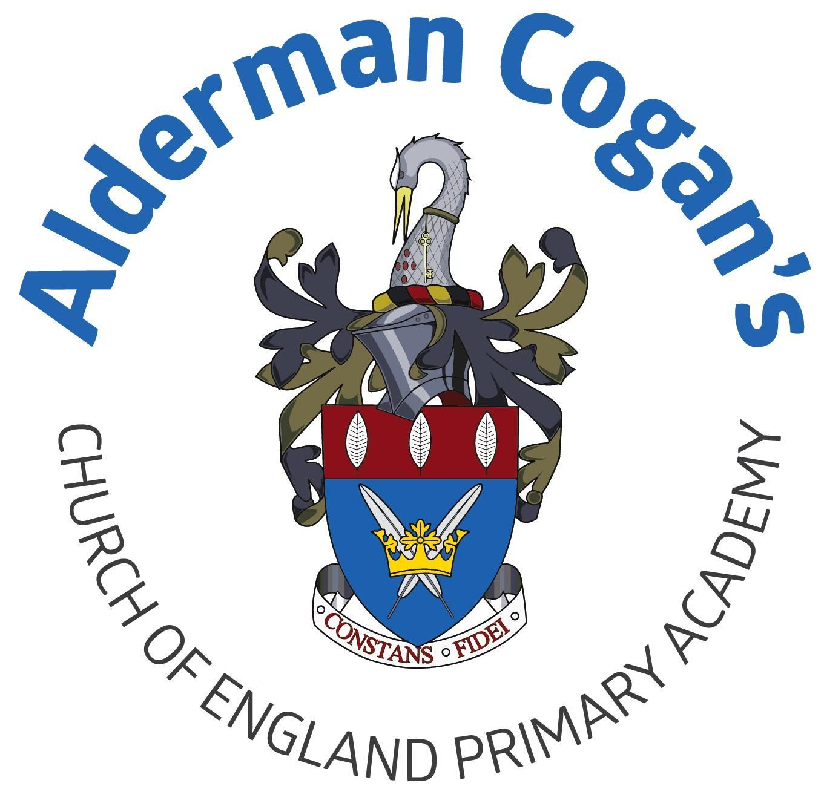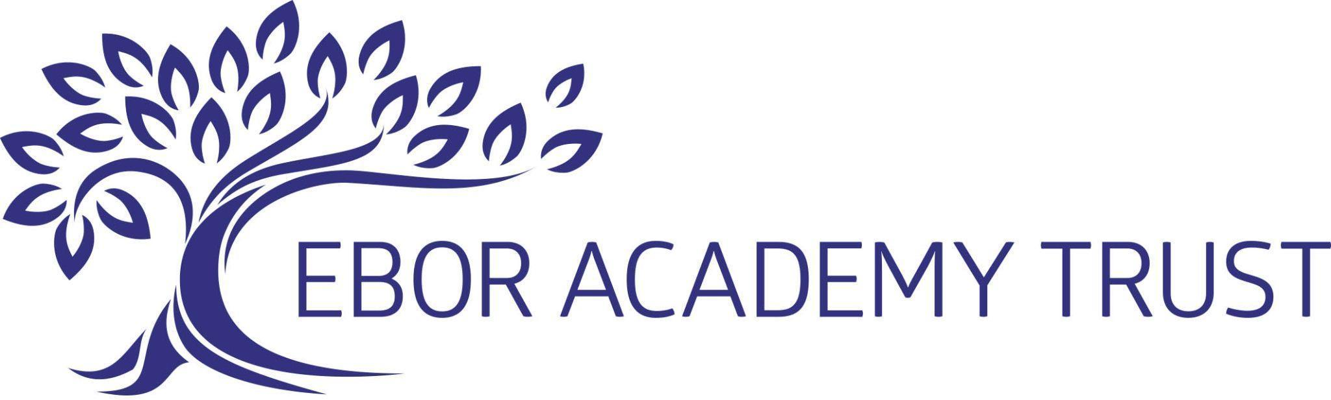

| **Year: 6**  **Autumn**  **Distortion and Abstraction**  **Art** | | | | | |
| --- | --- | --- | --- | --- | --- |
| **Previous learning** | | | | | |
| In art and design, children explore the artistic concepts of abstraction and distortion. They learn about the Abstract art movement and some of its derivative movements, including Cubism and Orphism. During the Bees Beetles and Butterflies project, children revisit the theme of nature and the natural world. They learn about significant printmaker, Andy Warhol, and they use what they have learnt to create Pop Art bees. This project teaches children about the concepts of abstraction and distortion. They study the visual characteristics of abstraction and create a musically-inspired, abstract painting | | | | | |
| **Substantive Knowledge in Art** | | | **Disciplinary knowledge in Art** | | |
| The development of the formal elements by introducing and experiencing a wide range of media, using associated key vocabulary and knowing the work and techniques of a wide range of artists, craftspeople and designers. As pupils progress, they should be able to think critically and develop a more rigorous understanding of art and design as they develop skills and knowledge. They should also know how art and design both reflect and shape our history, and contribute to the culture, creativity and wealth of our nation. At the end of Key Stage Two, children of Alderman Cogan will be able to work independently to take action and refine their technical and craft skills in order to improve their mastery of materials and techniques. | | | Creatively thinking of possibilities, making comparisons, questioning and critiquing, reaching judgements, addressing challenges and reflecting on the impact of works of Art and Design produced independently, collectively and by others. Presenting outcomes verbally and in written form. | | |
| Sticky knowledge   * Distortion alters shapes, abstraction removes realistic depictions, and exaggeration makes things larger than life * Line is the basic element of drawing, used for outlines, contours, and shading through techniques like cross-hatching, while tone refers to lightness and darkness. * Perspective includes one-point, two-point, and three-point perspectives, which determine how objects are viewed in relation to the horizon line. | | | | | |
| Lesson 1 | | **Exploring & Developing Ideas** | | | |
| * In art, distortion is an alteration to an original shape, abstraction refers to art that doesn't depict the world realistically and exaggeration is the depiction of something that is larger than in real life. * Use distortion, abstraction and exaggeration to create interesting effects in portraiture or figure drawing. | | | |
| Lesson 2 | | **Exploring & Developing Ideas** | | | |
| * Line is the most basic element of drawing and can be used to create outlines, contour lines to make images three-dimensional and for shading in the form of cross-hatching. Tone is the relative lightness and darkness of a colour. Different types of perspective include one-point perspective (one vanishing point on the horizon line), two-point perspective (two vanishing points on the horizon line) and three-point perspective (two vanishing points) the horizon line and one below the ground, which is usually used for images of tall buildings seen from above). * Use line, tone or shape to draw observational detail or perspective. | | | |
| **Vocabulary** | | | | | |
| observation, tonal contrast, mixed media, shading, hatching, blending, stencilling technique composition: perspective, single focal point, horizon, composition, scale, | | | | | |

| **Year: 6**  **Spring**  **Frozen Kingdoms**  **Inuit Art - Printing**  **Art** | | | | | |
| --- | --- | --- | --- | --- | --- |
| **Previous learning** | | | | | |
| In art children build upon their prior knowledge of animals in art from the Year 4 unit Animals and observe the style and methods of Inuit artists. This project teaches children about the Inuit way of life, including some of their cultural and artistic traditions. | | | | | |
| **Substantive Knowledge in Art** | | | **Disciplinary knowledge in Art** | | |
| The development of the formal elements by introducing and experiencing a wide range of media, using associated key vocabulary and knowing the work and techniques of a wide range of artists, craftspeople and designers. As pupils progress, they should be able to think critically and develop a more rigorous understanding of art and design as they develop skills and knowledge. They should also know how art and design both reflect and shape our history, and contribute to the culture, creativity and wealth of our nation. At the end of Key Stage Two, children of Alderman Cogan will be able to work independently to take action and refine their technical and craft skills in order to improve their mastery of materials and techniques. | | | Creatively thinking of possibilities, making comparisons, questioning and critiquing, reaching judgements, addressing challenges and reflecting on the impact of works of Art and Design produced independently, collectively and by others. Presenting outcomes verbally and in written form. | | |
| Lesson 1 | | **Exploring & Developing Ideas** | | | |
| * Know that different artistic movements often use colour in a distinctive way. Expressionist artists use intense, non-naturalistic colours. Impressionist artists use complementary colours. Fauvist artists use flat areas or patches of colour. Naturalist artists use realistic colours. * Can use a colour palettes and characteristics of an artistic movement or artist in artwork. | | | |
| Lesson 2 | | **Exploring & Developing Ideas** | | | |
| * Can create a mood board is an arrangement of images, materials, text and pictures that can show ideas or concepts. A montage is a set of separate images that are related to each other and placed together to create a single image. | | | |
| Lesson 3 | | **Exploring & Developing Ideas** | | | |
| * Can gather, record and develop information from a range of sources to create a mood board or montage to inform their thinking about a piece of art. | | | |
| **Vocabulary** | | | | | |
| digital mood board, montage, mood board, colour, form, montage, observation, pattern, shape, discussion, experimentation, exploration, information, inspiration, montage, research, annotation, colour swatch | | | | | |

| **Year: 6**  **Summer**  **Maafa-print making**  **Art** | | | | | |
| --- | --- | --- | --- | --- | --- |
| **Previous learning** | | | | | |
| In art children build upon their prior knowledge of animals in art from the Year 4 unit Animals and observe the style and methods of African artists. This project teaches children about significant black artists and their work, and provides opportunities to analyse and create artwork inspired by them. | | | | | |
| **Substantive Knowledge in Art** | | | **Disciplinary knowledge in Art** | | |
| The development of the formal elements by introducing and experiencing a wide range of media, using associated key vocabulary and knowing the work and techniques of a wide range of artists, craftspeople and designers. As pupils progress, they should be able to think critically and develop a more rigorous understanding of art and design as they develop skills and knowledge. They should also know how art and design both reflect and shape our history, and contribute to the culture, creativity and wealth of our nation. At the end of Key Stage Two, children of Alderman Cogan will be able to work independently to take action and refine their technical and craft skills in order to improve their mastery of materials and techniques. | | | Creatively thinking of possibilities, making comparisons, questioning and critiquing, reaching judgements, addressing challenges and reflecting on the impact of works of Art and Design produced independently, collectively and by others. Presenting outcomes verbally and in written form. | | |
| Lesson 1 | | **Exploring & Developing Ideas** | | | |
| * Know that works of art can be significant for many reasons. For example, they are created by key artists of an artistic movement; have influenced other artists; have a new or unique concept or technique or have a famous or important subject. * Be able to understand the significance of different artworks from a range of times and cultures and use elements of these to create their own artworks. | | | |
| Lesson 2 | | **Exploring & Developing Ideas** | | | |
| * To understand printmakers create artwork by transferring paint, ink or other art materials from one surface to another. * Can use the work of a significant printmaker to influence artwork. | | | |
| Lesson 3 | | **Exploring & Developing Ideas** | | | |
| * Know that a 3-D form is a sculpture made by carving, modelling, casting or constructing. * Can create a 3-D form using malleable materials in the style of a significant artist, architect or designer. | | | |
| **Vocabulary** | | | | | |
| relief or impressed, overlays, layers, depth, 3-D form, carve, soapstone, intricate patterns, textures, malleable, clay, coils, slips, slabs, coils, slips, materials, sculptures | | | | | |

| **Year: 6**  **Summer**  **Environmental Artists**  **Art** | | | | | |
| --- | --- | --- | --- | --- | --- |
| **Previous learning** | | | | | |
| This project teaches children about the genre of environmental art. They study how artists create artwork that addresses social and political issues related to the natural and urban environment. Children work collaboratively to create artwork with an environmental message. | | | | | |
| **Substantive Knowledge in Art** | | | **Disciplinary knowledge in Art** | | |
| The development of the formal elements by introducing and experiencing a wide range of media, using associated key vocabulary and knowing the work and techniques of a wide range of artists, craftspeople and designers. As pupils progress, they should be able to think critically and develop a more rigorous understanding of art and design as they develop skills and knowledge. They should also know how art and design both reflect and shape our history, and contribute to the culture, creativity and wealth of our nation. At the end of Key Stage Two, children of Alderman Cogan will be able to work independently to take action and refine their technical and craft skills in order to improve their mastery of materials and techniques. | | | Creatively thinking of possibilities, making comparisons, questioning and critiquing, reaching judgements, addressing challenges and reflecting on the impact of works of Art and Design produced independently, collectively and by others. Presenting outcomes verbally and in written form. | | |
| Lesson 1 | | **Exploring & Developing Ideas** | | | |
| * Know that materials have different qualities, such as rough or smooth, hard or soft, heavy or light, opaque or transparent and fragile or robust. These different qualities can be used to add texture to a piece of artwork. | | | |
| Lesson 2 | | **Exploring & Developing Ideas** | | | |
| * Can combine the qualities of different materials including paper, fabric and print techniques to create textural effects | | | |
| **Vocabulary** | | | | | |
| Mixed media, texture, colour, contrast, bold, subtle, impact. | | | | | |